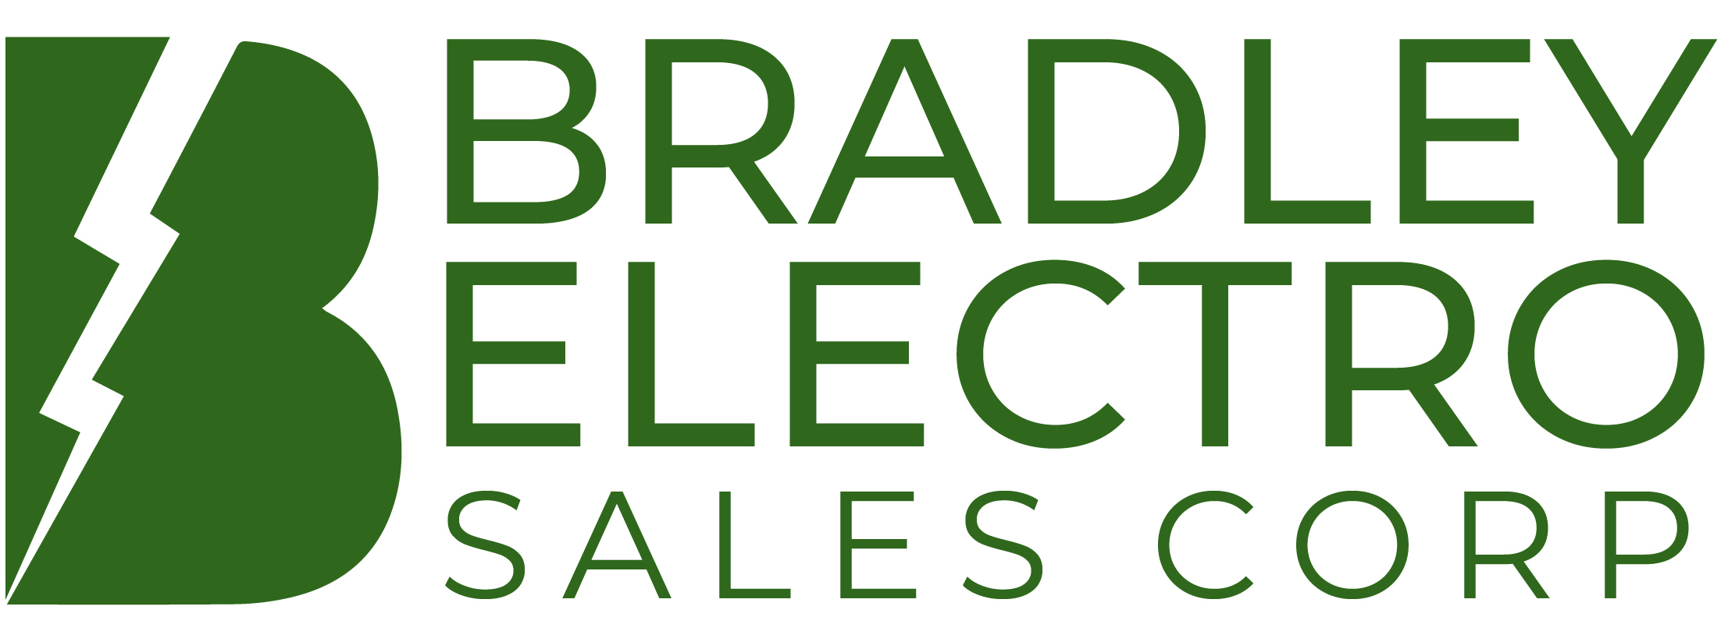

10909 Southlake Court 1628A Postal Road

North Chesterfield, Virginia 23236 Chester, Maryland 21619

Phone: (804) 320-8005 Phone: (410) 266-8484

Fax: (804) 320-8006 Fax: (410) 266-8485

Email: Richmondoffice@bradleyelectro.com
Website: www.bradleyelectro.com

ADVANCED POWER TECHNOLOGIES….………………………………….……..Transformer Monitoring Devices
ALMETEK………………...……..………………ANSI Labels and Safety Signs, Custom Signs, Identification Systems
BUCKINGHAM………………….……………Lineman Climbing Equipment, Fall Protection, Tools and Accessories
CEMBRE……………………………..………...…….Battery, Hydraulic and Manual Compression and Cutting Tools
CEMENTEX…………………….……………………....……Insulated Hand Tools, Protective Clothing & Accessories
EFFECTIVE SAFETY PRODUCTS ………………Professional Lineman Products, Made by Lineman for Lineman
FEDERAL SIGNAL CORP…………………...…….…………….………..…………Audible/Visual Signaling Products
HOWARD TRANSFORMERS……...……..……….…Single-&Three-Phase Liquid filled Distribution Transformers
KELVION.......................................………………………………….………Transformer Cooling Systems & Oil Pumps
MADI…………………………………………………………………….Tri-Penta Wrench, BRUSHBLADE, DEVINER
MCR SAFETY……………………………………………………………………………...Gloves, Glasses and Garments
OLSUN ELECTRICS CORP …………..Single- & Three-Phase Dry-Type, Encapsulated & Cast Coil Transformers
PFIFFNER………………………………………………………………………………..………Instrument Transformers
PHENIX TECHNOLOGIES............................High Voltage, High Current, High Power Test Systems & Components
PHOENIX ELECTRIC CORP………………………………………………………………………….Air Core Reactors
POWER DESIGN, INC. ...…Fiberglass Cable Junction Cabinets, Pad-Mount & Direct-Bury Enclosures; Buildings
PROLEC/GE – WAUKESHA……………..…....Power Transformers, Service & Maintenance, Components & Parts
SHAWFLEX/DSG-CANUSA.………Medium-Voltage Terminations & Splices, Heat-Shrink Tubing, Related Training
S&C ELECTRIC COMPANY……...….Overhead & Underground Switchgear, Fuses, Switch & Capacitor Controls
SAFETY ONE TRAINING……………………………………………………………………….Fall Protection Training
UNDERGROUND DEVICES…………………...………...…Duct Spacers, Bore Spacers, & Nonmetallic Cable Racks
W.J. WHATLEY (VALMONT)…………………………………………………………………Fiberglass Lighting Poles
3B PROTECTION BALLISTIC/BLAST/BREAK-IN……...Smart ballistic protection systems, innovative security solutions for critical infrastructure.

TERRITORY
DISTRICT OF COLUMBIA, DELAWARE, MARYLAND, VIRGINIA, AND WEST VIRGINIA
(NOT ALL MANUFACTURERS REPRESENTED IN ALL TERRITORIES)

MEMBER OF NEMRA, EERA, MANA

SERVING THE ELECTRICAL INDUSTRY SINCE 1922

